**Project 01 – Interpret a Data Visualization**

Author: Nélio Manuel Macombo

**Summary**

* This project has the purpose to demonstrate the understanding of the data to report business findings, which on this case be the presentation of three insights from a chosen dashboard;
* Chosen Dashboard: [LinkedIn Top Skills](https://public.tableau.com/profile/matt.chambers#!/vizhome/LinkedInTopSkills2016-MakeoverMonday/LinkedInTopSkills2016-MakeoverMonday)

1. **Top LinkedIn Skills for 2016 in South Africa**

* Analyzing the data in South Africa I found that the most of the skills that lies under the Global Average Rank are also part of this country and there are majorly six skills demanding in this country where the highly demanding are: Statistical Analysis & Data, Network & Information Security & Mobile Development.

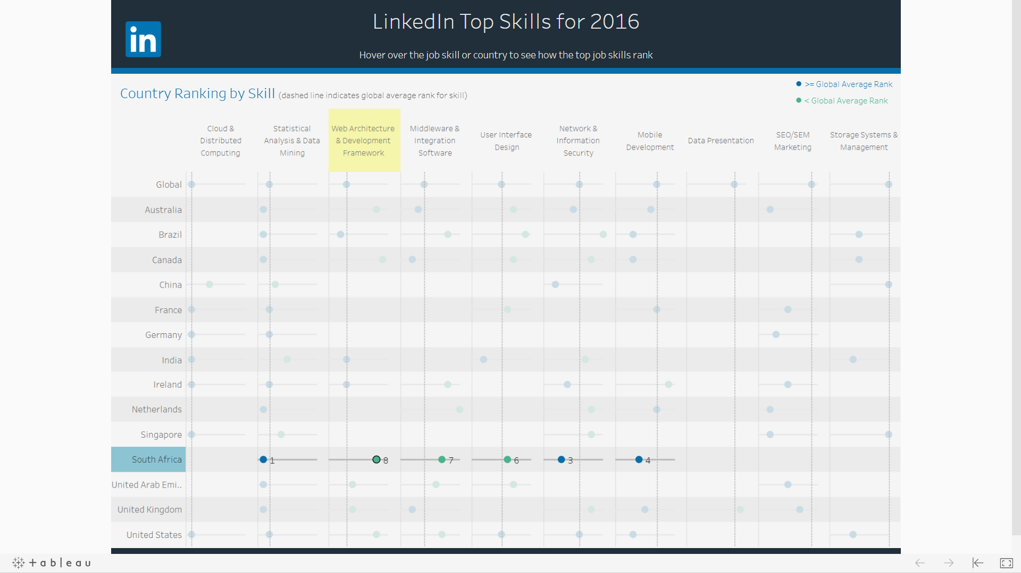

1. **The Trend Skill demanding around the world: Statistical Analysis & Data Mining**

* Analyzing the data on the dashboard, I can conclude that Statistical Analysis and Data Mining this is the one of most demanding skill around the world by LinkedIn in 2016 (in the global ranking it is at #2) mentioned all countries representing a worth skill to invest in order to get hired worldwide.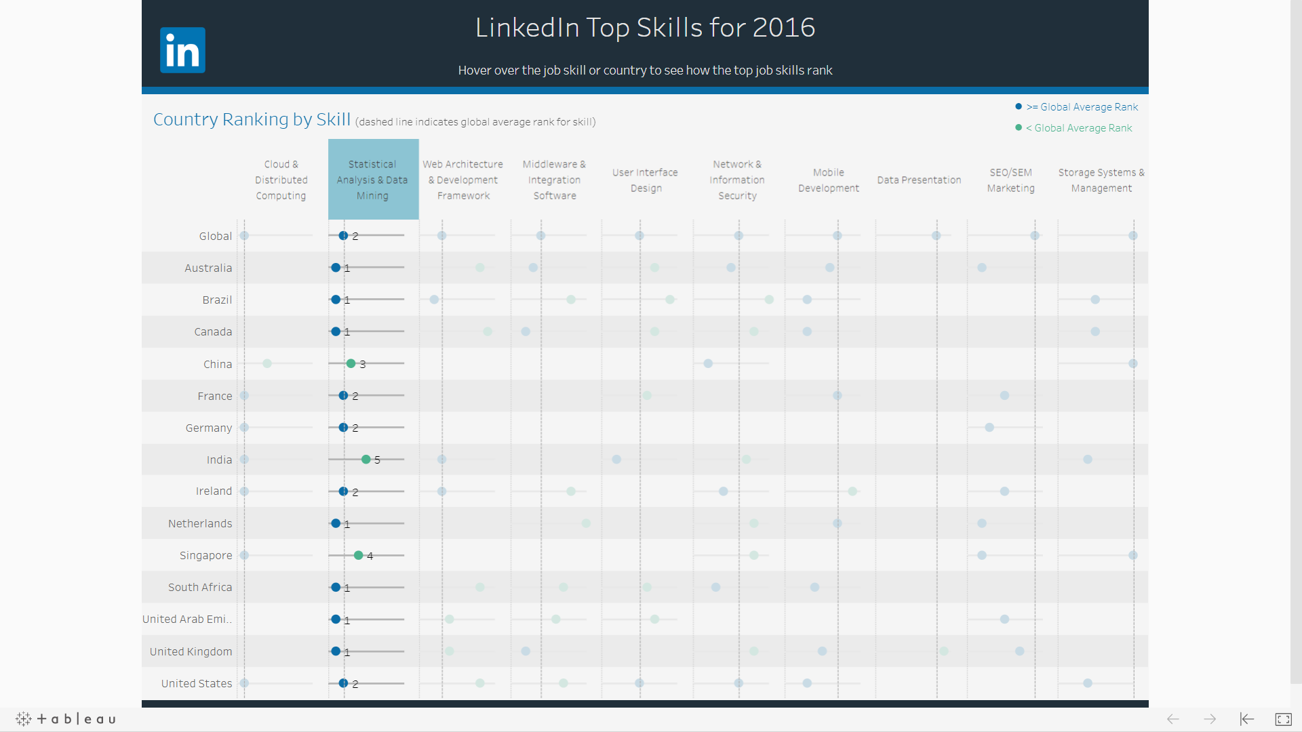

1. **Skill on growing around the world for 2016: User Interface Design**

* 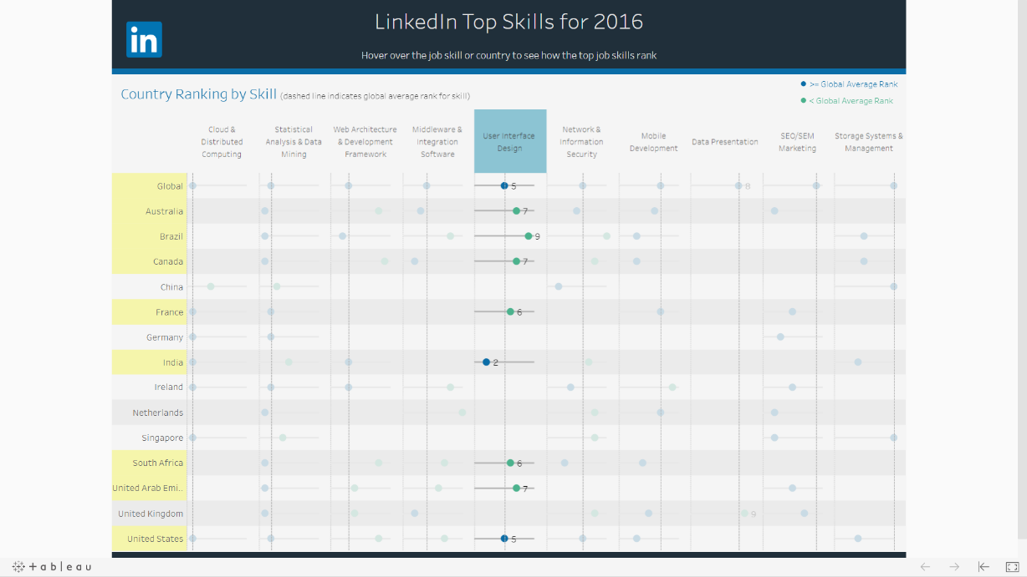The User Interface Design is winning traction around the World (in the global ranking it is at #5) and on upcoming years will be relevant on ICT Industry. As I see on the Dashboard, this skill has variance responses, and major of the countries are ranking it as below than the Global Average Rank, while others are higher. From the data presented on dashboard, I can conclude that User Interface Design is a specialty area that the countries should work in, or outsource the projects to the countries that specialized in that area.